8.1
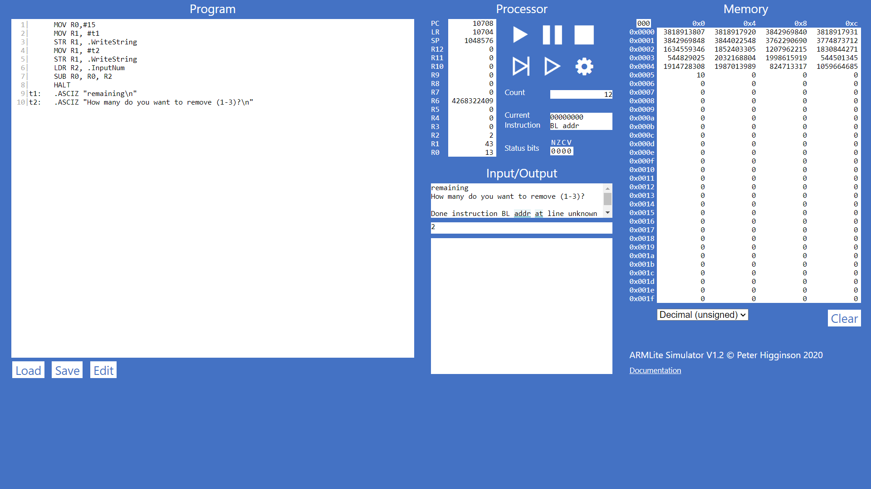
8.2.1
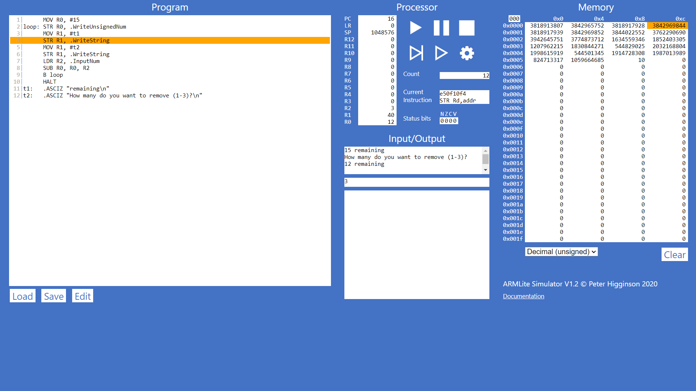
What happens if you enter a number that takes the number of matchsticks remaining beyond 0 (i.e., into negative values) ? What do you think is going on here ? Hint - take a look at the value in the register!
When the number of matchsticks is a negative one (-x , x>0), the output will be (2³² – x)
8.2.2
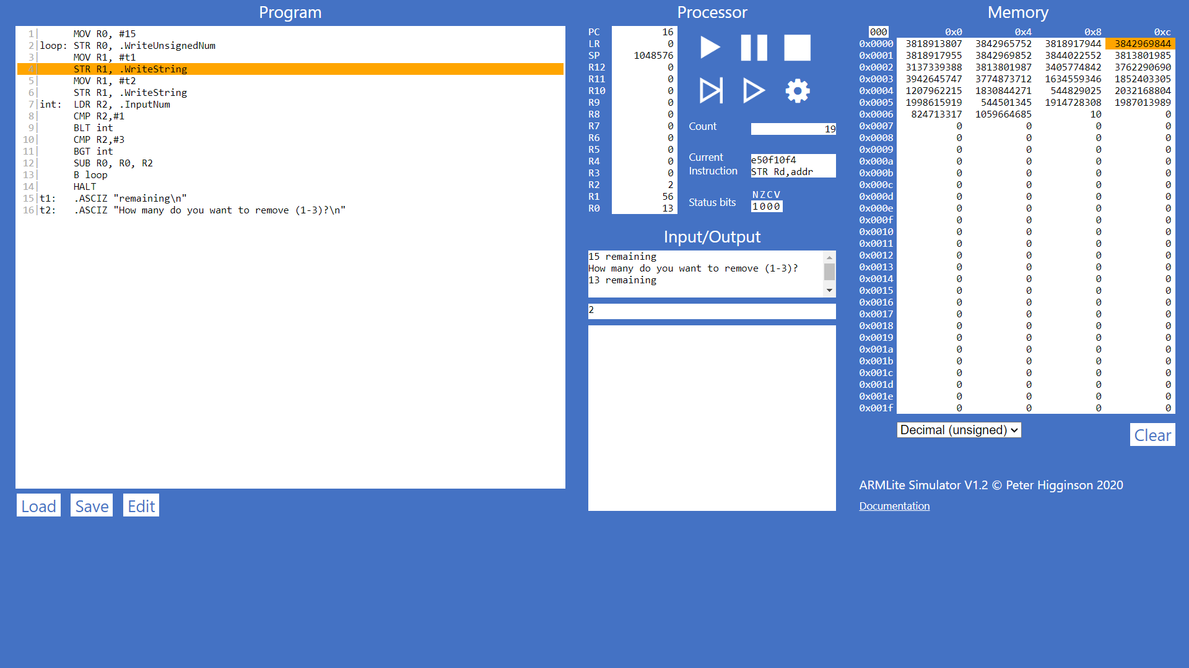
c) If the input = 0, because of R2=0 < 1, the N status bit is now 1
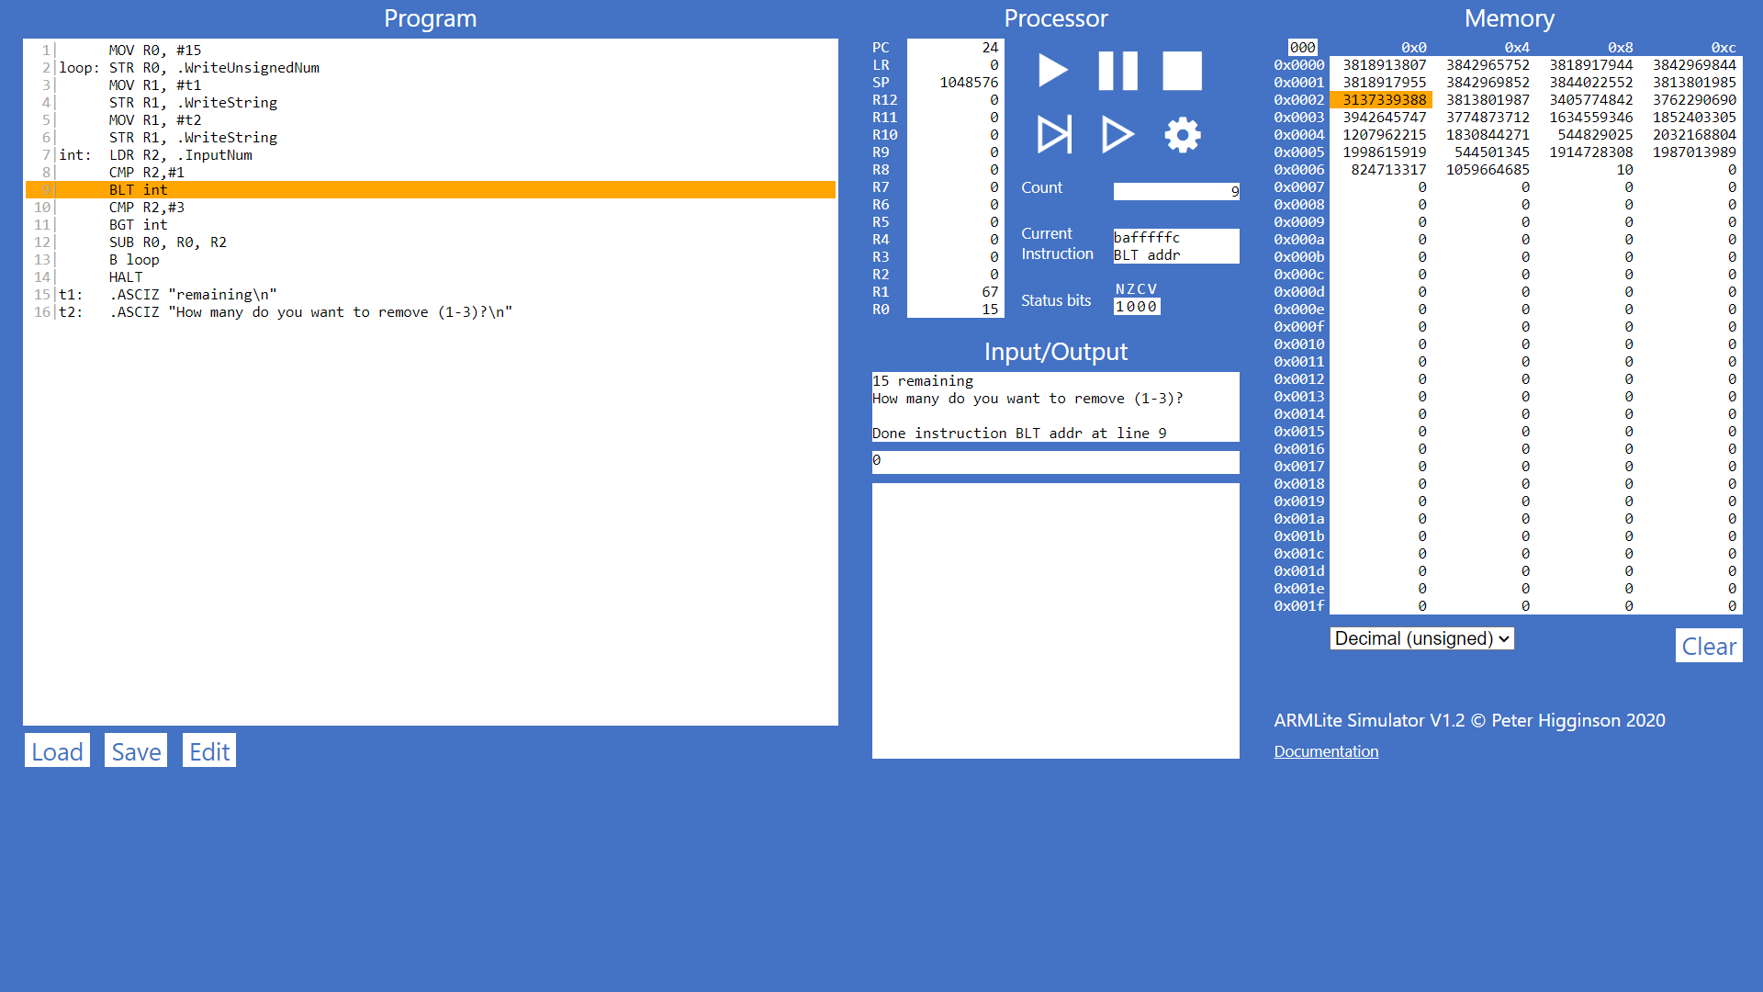
8.3
8.4
